***Video* Design *Motion Graphic* Based *Company Profile* as Publication Media Pt. Muliaoffset Packindo Semarang City**

**(Case study: PT. Muliaoffset Packindo Semarang)**

**Lukas Dwi Santoso**

Universitas Sains dan Teknologi Komputer[Lukass.santoso@gmail.com](mailto:Lukass.santoso@gmail.com)

**Sarwo Nugroho**

Universitas Sains dan Teknologi Komputer[Lukass.santoso@gmail.com](mailto:Lukass.santoso@gmail.com)

***Abstract:*** *Competition in the business world is getting tougher day by day. The increasing market demand for product requirements has triggered the emergence of new companies that continue to grow. Because of this, good and communicative marketing is needed as a means of introducing the company to consumers so that the company or business being run can be widely known and continue to compete with other competitors. Publication media is currently increasingly varied and interesting. Technological advances indirectly force graphic designers to continue to develop and produce work that is fresh and up to dateThere are more and more innovations and significant developments in the world of publications as time goes by. Unlike before, today's publication media is dominated by non-print media. Before the widespread use of the internet and smartphones , publication media was dominated by print media such as; brochures, posters, billboards, banners and other printed media. Ease of access is one of the main factors causing the rise of non-physical publication media. Information about a company can be accessed more easily and practically, compared to using print media which is starting to be replaced. Company profile videos This contains, among other things ; company background, address, telephone number, email , website , and other information that needs to be displayed about PT. Muliaoffset Packindo. Videos company profile Motion graphic- based has a relatively short duration but is packaged in an interesting way, because of the movement animations and transitions applied to each frame. After seeing the company's company profile video , the audience expects interested with the information presented and get to know more about the company .*

***Keywods:*** *media, publication, company profile, motion graphics.*

1. **Background**

Technological advances make it easier for humans to fulfill various needs, one of which is communication. This convenience is also used by companies as a means of publication. The method that companies usually use for publication is print media such as posters, *banners*, brochures, calendars, business cards, mass media advertisements (newspapers, magazines, tabloids), catalogs ( *company profiles* ), and so on. However, print media needs to be complementary to maximize publications in the current digital era, namely by using *company profile videos.*

*Video* is a practical way to convey information, because *videos* contain images, sound and text simultaneously so that the information is more interesting to listen to and understand. *Videos* *Motion graphics* themselves emphasize unique motion animations and transitions and give the audience the impression of curiosity about what will be shown in the next *frame* , so they are interesting and not boring. With a relatively short duration, *video* *Motion graphics* present information packaged in an attractive but easy to understand manner by combining animation, text, transitions and images designed so that the information presented can be well received by the audience.

PT. Muliaoffset Packindo is a company operating in *the offset packaging sector* . The products produced are packaging made from cardboard, ranging from food packaging, medicine packaging as well as other products that require boxes or *packaging.*

PT. Muliaoffset Packindo still uses print media (catalogs) as company publication media . With *video* *company profile* It is hoped that it can complement existing publication media. *Videos* It is hoped that *the motion graphic* -based *company profile* will attract attention when broadcast at *job fair activities* and the information presented can be conveyed to many people. Unlike catalogs that need to be printed and read by individuals, *videos* can be displayed on monitors and viewed by many people. Catalogs also require quite expensive printing costs and are easily damaged if used frequently, while *videos* can be played continuously without worrying about the files being damaged damaged. Based on this problem, the author proposes a title: " *Video Design* *Motion Graphic* Based *Company Profile* as PT Publication Media. Muliaoffset Packindo Semarang City”.

1. **Identification of problems**

Publication media at PT Muliaoffset Packindo is still print media (catalog) and does not yet have *videos* *company company profile* .

1. **Formulation of the problem**

How to present *videos* *motion graphic* based *company profile* as a publication medium so that information about PT Muliaoffset Packindo can be summarized completely and can be made into *a video* informative and interesting *company profile ?*

1. **Restricting the problem**
2. Using *Adobe After Effect CS6* and *Adobe Premiere Pro CS6 software* for *video editing* .
3. Using *Adobe Illustrator CS6 software* for image *editing* .
4. Using the *.mp4 video format* as the final *video result* with *video quality of* 720x480 *pixels*
5. Using instrumental music as *video background sound* .
6. *The video* is designed using *motion graphic techniques* and only contains general company information for company publications such as:
7. Company logo
8. Brief history of the company
9. Vision and mission of the company
10. *contact* (address, telephone number, *website, email* )
11. Description of the products produced
12. Overview of order processing stages
13. **Research purposes**

Designing a PT *company profile video* . Muliaoffset Packindo's informative and interesting *video-based motion graphics* for company publication.

1. **Benefits of research**
2. Benefits for Institutions:
3. Can be used as *a company company profile video*.
4. Can be used as company publication media.
5. Makes it easier for company publications.
6. Benefits for Academics:
7. Can be used as a reference for other students who want to conduct research using the same method in the future.
8. Benefits for writers:
9. Can apply the knowledge that the author has learned during college.
10. Gain experience designing *company company profile video*.
11. **Understanding Media**

The word media comes from the Latin *medius* which literally means middle, intermediary or introduction. In Arabic, media is an intermediary or messenger from the sender to the recipient of the message (Azhar Arsyad, 2011:3).

Meanwhile, according to Criticos quoted by Daryanto (2011: 4), media is a component of communication, namely as a messenger from the communicator to the communicant.

From the two opinions above, it can be concluded that the media is an intermediary tool for carrying out communication between the sender and recipient of the message.

1. **Definition of Publication**

According to the Merriam-Webster Dictionary, publication is any action or design/product design that attracts an audience, such as information that has news value so that it attracts the attention and support of the audience (Liliweri, 2011: 458).

Meanwhile, according to Nisberg, in the book communication, all-round, all-meaning, states that publication is information designed to show, introduce, defend the name and honor of a person, group or organization to the public in a certain context through the media with the aim of creating audience attraction (Liliweri , 2011).

From the existing opinions, it can be concluded that publications are information that is designed to be as attractive as possible to attract the attention of the public in order to introduce an organization, group or individual.

1. **Definition of Video**

Arief S. Sadiman (2009: 74) states that video is an audio-visual media that displays images and sound. The messages presented can be factual (events, important events, news) or fictional (such as stories), can be informative, educational or instructional.

Cecep Kustandi (2013: 64) stated that video is a tool that can present information, explain processes, explain complex concepts, teach skills, shorten or slow down time and influence attitudes. Here are some frequently encountered video formats:

1. *Audio Video Interlive (AVI) (*.avi)*

This *video* format was created by *Microsoft* in 1992. The characteristic of *AVI video* is that it is not compressed. Because it is not compressed, *AVI videos* look better and have better quality. However, the *AVI file size* becomes relatively large.

1. *MPEG-4 (MP4) (*.mp4)*

*video* format created by an organization called *MPEG. This video* format uses *H.264* compression for *the video* and *AAC* for the audio which produces good quality even though it has a small file size.

1. *Flash Video Files (FLV) (*.flv)*

Developed by *Adobe* , *FLV* is one of the most widely used *video formats for streaming media* on the internet. One of the advantages of this *video format* is its relatively small size.

1. *Quicktime (MOV) (*.mov)*

*One of the advantages of this video format made by Apple is that it supports Virtual Reality (VR). It has a fairly large file size but has very good quality.*

According to the opinion above, it can be concluded that *video* is a medium that displays images and sound containing information about an event or story.

Writer choose to use *the* . *mp4 is the final result because it has* good audio and *video quality even though it has a* small *file size.* Another reason the author chose *.mp4 files* was the *video application* *Players* generally support playback of this *file* , because the format is widely used .

1. **Understanding *Company Profile***

According to Maimunnah et al in the CCIT journal Vol5 No.3 (2012: 284) *a company profile* is an asset of an institution or company that can be used to improve an *image* of the company to collaborate with company relations, institutions and other related agencies. The *Company Profile* is a company asset that is held and owned by each company or institution.

*A company profile* is a product written by a *Public Relations (PR) practitioner* which contains a general description of the company. This picture is not completely complete, detailed and in-depth. Companies can choose what points they want to convey openly to the public. There are even companies that choose to create *a company profile* based on the interests of the target public. There are *company profiles* created specifically for consumers (customers), for banks, for the government, suppliers and so on. Usually this is done by large companies that have broad business fields and different publics (Kriyantono, 2009).

From the explanation above, it can be interpreted that *a company profile* is an asset belonging to a company which contains a general description of the company. The contents of *the company profile* are determined by the company and are not completely complete, only the points you want to display to the target audience.

1. **Understanding *Motion Graphics***

Wardhani, (2014: 3) in his journal explains: " *Motion graphics* are graphics that use *video* and/or animation to create the illusion of movement or transformation. *Graphic design* has changed from *static* publishing to utilizing communication technology including film, animation, interactive media, and *environmental design* .

*Motion graphics* are pieces of time-based visual media that combine film and graphic design. This can be achieved by combining various elements such as 2D and 3D animation, *video* , film, typography, illustration, photography and *music* (Sukarno 2014).

From the description above, it can be concluded that *motion graphics* are *videos* that contain animation to create the illusion of movement and are combined with various graphic elements such as typography, illustrations and music.

1. **Understanding Images**

According to Cecep Kusnandi, et al (2013). Image media is media that functions to convey messages through images that involve the sense of sight. The message conveyed is expressed through visual communication symbols. Image media aims to attract attention, clarify material, illustrate facts and information.

Richard E Mayer (2009) states that image media is any form of static or dynamic graphics, including: photos, graphics, plans, illustrations (which consist of two or more images), and also animations or cartoons. The act of establishing a connection between mental verbal and mental *pictorial* is an important step in conceptual understanding. Material delivered using well-constructed multimedia should be better at receiving messages than just words.

From the two explanations above, it can be concluded that images are static or dynamic media that are used to illustrate information so that messages can be well received by translating them into visual communication symbols.

1. Image Category

The image categories that are often used are:

1. *Bitmap* Image

*bitmap* image is a collection of bits that form an image. The image contains units of dots (or *pixels* ) that have their own color (called *bytes* , the smallest unit of information on a computer). The more *pixels* there are in an image, the smoother and more realistic the image.

1. Vector Image

Vector graphics are images displayed using mathematical definitions. Vector graphics is one method that can create the best results and is used by most image applications today.

1. Image Formats
2. *JPEG* image

*JPEG* image format or what is also commonly called the *JPG image format* is an abbreviation for *Joint Photographic Experts* *Assemble* . The definition of *the Joint Photographic Experts Assemble (JPEG)* image format is an image format that compresses image data by reducing parts of the image to block *pixels* in the image.

1. *PNG* image

*PNG* stands for *Portable Network Graphics* . The definition of the *Portable Network Graphics (PNG)* image format is an image format that is a combination of the *JPG* and *GIF formats* . *PNG* has a compression factor of around 5%-25% which is better than *GIF* , however *PNG* has a larger *file size than JPG* .

1. *GIF* images

*GIF* image format is the abbreviation of *Graphics Intercharge Format* , which is an image format with 8 bit color. *GIF* has fewer color combinations when compared to *JPEG* . However, *GIF* is capable of storing graphics with a transparent background or in the form of simple animation.

1. *BMP* image

Understanding image format *Bitma p* or *BMP* is a graphic image representation consisting of an arrangement of dots ( *pixels* ) stored in computer memory. The value of each point is preceded by one or more data bits. The dot density is usually called resolution Which serves to indicate the level of sharpness of the displayed image.

1. *TIFF* images

*TIFF* is an abbreviation for *Tagged Image Format File* . Understanding image formats *Tagged Image Format File* is the best image format because of its ability to guarantee that all data and information such as *RGB data, CMYK* data and other data can be corrected or manipulated in the image so that it is not lost.

1. **Framework of thinking**

The following is a framework for thinking in designing PT's *company profile video* . Muliaoffset Packindo:

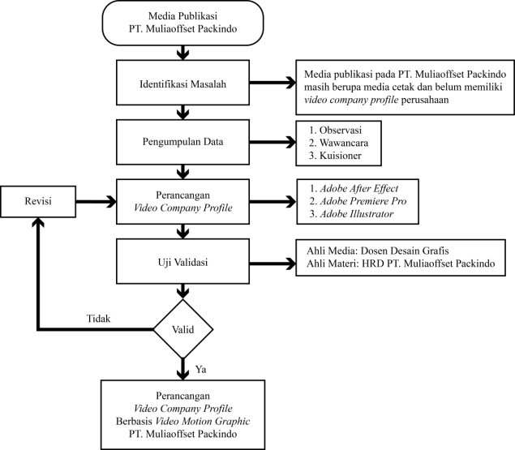

1. **Product Specifications**
2. The product created is *a company profile video* company that contains information aboutPT. Muliaoffset Packindo, starting from company history, company vision and mission to the products produced. This *video is based on motion graphics* which contains interesting animations. *Video* is used as a company publication medium.
3. The type of media created is *video* *motion graphics* containing:
4. Text
5. Animation
6. Picture
7. Audio
8. The information that will be displayed is:
9. Company name
10. Company history
11. Vision and mission of the company
12. Products produced
13. Company contact (phone number, email, website)
14. *The software* needed to design this *video* includes:
15. Adobe After Effects CC 2018
16. Adobe Premiere Pro CC 2018
17. Adobe Illustrator CS6
18. *Hardware* requirements for designing this *video* include:
19. Processor Intel(R) Core(TM) i5-6200U CPU @ 2.30GHz 2.40 GHz
20. 14″ screen
21. RAM 4gb
22. 64-bit operating system
23. Windows 10
24. **Development Methods**

In this research the author will use the *research and development (R&D)* method. Sugiyono (2013:297) revealed that the *research and development method* is a research method used to produce certain products and test the effectiveness of these products.

1. **Trial Design**

|  |  |  |
| --- | --- | --- |
| No. | *Storyboarding* | Information |
| 1. | Description: #1-storyboard | *Opening* logo PT. Muliaoffset Packindo. The animation comes in from the bottom and then the company name appears from under the logo. |
| 2. |  | Brief introduction about the company |
| 3. | Description: #3-storyboard | Brief history of the company. Describes the company's progress from its inception to the present. |
| 4. | Description: #4-storyboard | The company's vision and mission uses typographic animation with various *motion effects.* |
| 5. | Description: #5-storyboard | *Map* / *direction* to get to PT. Muliaoffset Packindo. Using an animated *map to make it easier for the audience to understand the contents of the map* . |
| 6. | Description: #6-storyboard | *Working* *orders* , stages and processing *of orders* from design to finished goods in the hands *of customers* . Using *camera animation* *moving* from one stage to the next. |
| 7. | Description: #7-storyboard | The types of products the company produces. With *pop animation* *up* image as if the image came out of a book. |
| 8. | Description: #8-storyboard | *Closing* , contains *contact* *person* such as: *website* , telephone number, *email* and company address. |

1. **Final Product Discussion**

* 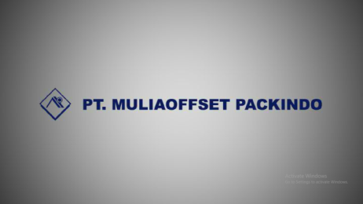Intro 1 final display
* 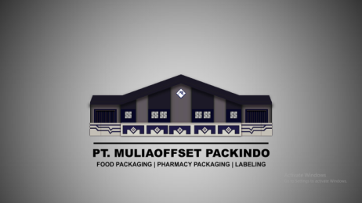Final intro 2 display
* 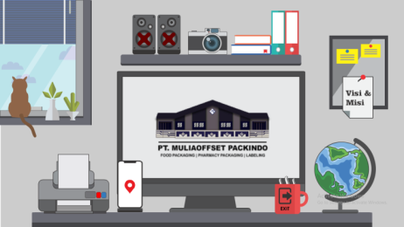Final display of the main *menu*
* 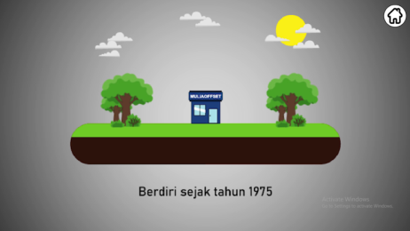The final display *of the video menu*
* 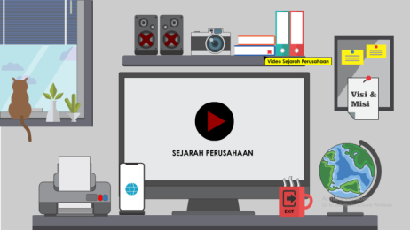Display final *playing video*
* Final *outro view*

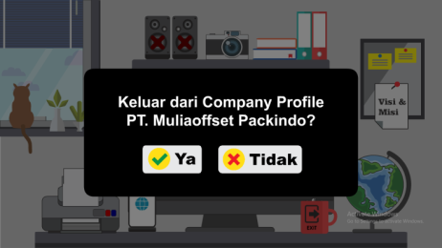

1. **Conclusion**

Based on the results of research, design and testing of *company profile videos* carried out at PT. Muliaofset Packindo Semarang City, the following conclusions can be drawn:

1. *Company profile videos* can be an interesting publication medium because the information displayed is packaged with unique animations so that they are not monotonous and do not make the audience bored.
2. With *background* music and narration that helps convey information, viewers can easily understand the information presented without worrying about missing the *video* .
3. The navigation buttons are designed to represent each linked *video and are animated to make them more interesting and not look boring.*
4. When designing *a company profile video* , you need to pay attention to all the information that will be displayed, arrange the words in the narrative so that it is easily accepted by the audience, and provide *background* music with a theme that suits *the video* .
5. The final score from the results of the questionnaire given to 25 respondents regarding the importance of using *company profile videos* was 90.08 %, which means that using *company profile videos* is very important.
6. The validation score from media experts is 3 7 which means the product is very valid. The validation score from material experts is 3.6 , which means the product is very valid for use as *a company profile video* , while the user assessment score regarding the product is 37.68 . which means it is valid for use.
7. **Product Limitations**

*company profile video* product has several limitations, including:

1. *company profile videos* can only be operated using a laptop or computer and cannot be operated via *Android* or *smartphone* .
2. *company profile video* cannot yet be accessed *online* .
3. **Suggestion**

Based on the research results, discussion and conclusions above, the suggestions that can be given in this research are:

1. It is hoped that future researchers can develop interactive *company profile videos that can be* operated via *Android* or *smartphone .*
2. future researchers can create interactive company profile videos that can be accessed online.

**BIBLIOGRAPHY**

Adinda & Adjie, 2011; *"3D Based 2d Animation Film Using Cell Shading Technique Entitled The Postman Story, 6",* Surabaya: Stikom, Final Project

Alo Liliweri, 2011; *“Multi-Meaningful Communication”,* Jakarta: Kencana

Andi, 2013; *"YOU CAN DO IT!! Learn Adobe Illustrator CS6 Yourself”,* Yogyakarta: Andi Publishers

Arief S. Sadiman, 2009 ; *“Educational Media”* , Jakarta: PT Raja Grafindo Persada

Arsyad, Azhar, 2011 ; *"Learning Media"* , Jakarta: PT Raja Grafindo Persada

AS, Ranang. H., Basnendar. NP, Asmoro, 2010 ; *"Cartoon Animation From Analog to Digital",* Jakarta: Index

Cecep Kusnandi, Bambang Sujtipto, 2013; *"Manual and Digital Learning Media"* , Bogor: Ghalia Indonesia p. 41-42

Daryanto, 2011 ; *“Learning Media”,* Yogyakarta: PT. Gava Media

Computer, Wahana, 2010 ; *"Adobe After Effect CS4 Practical Guide for Creating Video Effects"* , Yogyakarta: Andi Publisher

Kriyantono, R., 2009; *"Practical Communication Research Techniques"* , Jakarta: Prenada Media Group

Kustandi, Cecep, 2013; *"Second Edition Manual and Digital Learning Media",* Bogor: Ghalia Indonesia

Macdoms, 2012 ; " *Complete Review of Adobe Flash Professional CS6",* Yogyakarta: Andi

Maharsi, Indira, 2013; *"Typography - every font has life and meaning"* , Yogyakarta: *CAPS (Center for Academic Publishing Service)*

Maimunnah, et al, 2012; *"Media Company Profile as a Means of Supporting Information and Promotion",* Tangerang: Journal CCIT Vol. 5 No. 3:257,283,284

Pranowo, G. 2011 ; *“Interactive Animation Creation with Action Script 3.0 in Flash*

*CS5”,* Yogyakarta: Andi Offset.

Razaq, Abdul & Ispantoro, 2011 ; *"The Magic Of MOVIE EDITING: Creative Ways to Edit Videos",* Jakarta: Mediakita

Richard E Mayer, 2009 ; *"Multimedia Principles and Applications"* , Yogyakarta: Student library p. 95-99

Sanjaya, Vienna, 2010 ; *"Learning Strategies Oriented to Educational Process Standards",* Jakarta: Prenada Media Group

Sugiyono, 2013; *"Educational Research Methods Quantitative, Qualitative and R&D Approaches"* , Bandung: Alfabeta

Sukarno, Iman Satriaputra, 2014 ; *"Designing Illustrative Motion Graphics About Majapahit for Young People"* , Bandung: Journal of the Bachelor's Degree in Design Arts, ITB

Wardhani, Rahmi Kesuma, 2014; *"Autism Documentary Video Design",* Vol 3(1): 3